Implementation
AI-Assisted Verification of Fetal Biometric Measurements for Improved Diagnostic Accuracy in Obstetric Ultrasound
Milestone 3 — Final Draft
Prepared for: CST-590 Course Instructor (Project Advisor)
Prepared by: Andie Draucker
Document Contributors: Andie Draucker (sole author/developer)
Stakeholders: Andie Draucker (Student, Project Manager, Developer); CST-590 Course Instructor (Project Advisor / Approving Authority)
Program: MS Computer Science | Course: CST-590
Date Submitted: September 16, 2026
A companion source-code package (fetal_hc_qa/) and a separate User Guide document accompany this submission.

Implementation Overview
Milestone 1 defined a diagnostic-imaging quality-assurance / second-reader system that independently re-measures fetal head circumference (HC) from a 2D obstetric ultrasound image and flags any discrepancy from the sonographer's recorded value using evidence-based tiers (Sarris et al., 2012). Milestone 2 translated that proposal into a concrete architecture: eight collaborating classes (PipelineOrchestrator, DatasetLoader, ImagePreprocessor, HeadSegmentationModel, MeasurementExtractor, ComparisonEngine, PlaneQualityGate, DiscrepancyFlaggingEngine, GADayConverter, and ReportGenerator) and four data objects (UltrasoundCase, DiscrepancyResult, CaseReport, BatchSummaryReport), four algorithms, and a full set of screen and report specifications.
This Milestone 3 submission implements that architecture as a working Python package, fetal_hc_qa, with every class named in Milestone 2 built, unit-tested, and exercised end to end on a 60-case test dataset. The pipeline runs from the command line (python scripts/run_pipeline.py), loads each case, segments the fetal head, extracts an independent HC measurement, evaluates it through the plane-quality gate and tiered flagging engine, and renders both a per-case visual report and a batch evaluation summary — reproducing, with real data and real output, the exact sequence of operations specified in Milestone 2's collaboration diagrams.
Two implementation decisions depart from the exact technology named in Milestone 2 and are disclosed in full in the Implementation Plan section of this document (“Known Deviations and Reconciliation Plan”): the segmentation backend uses classical computer-vision techniques rather than a trained U-Net, and the dataset used for this build is a schema-identical synthetic stand-in for the real HC18 Grand Challenge dataset. Both substitutions were necessitated by the offline, GPU-free development environment used to build this milestone, both sit behind the exact interfaces Milestone 2 specified for their real counterparts, and both are fully reversible with no code changes elsewhere in the pipeline. This section exists specifically so that no reader mistakes either substitution for the originally scoped, internet-and-GPU-dependent components.

System Entities
The system's data model consists of four plain data objects (Python dataclasses), matching the Milestone 2 UML class diagram exactly, plus one enumeration (Tier) that defines the five possible discrepancy outcomes. These objects are deliberately dependency-free — no entity depends on any service class — so that every service class listed later in this document can be unit-tested by constructing entities directly, without running the rest of the pipeline. Figure 1 (reproduced from Milestone 2, unchanged, because the Milestone 3 build required no revision to this design) shows how the service classes construct and pass these entities to one another.
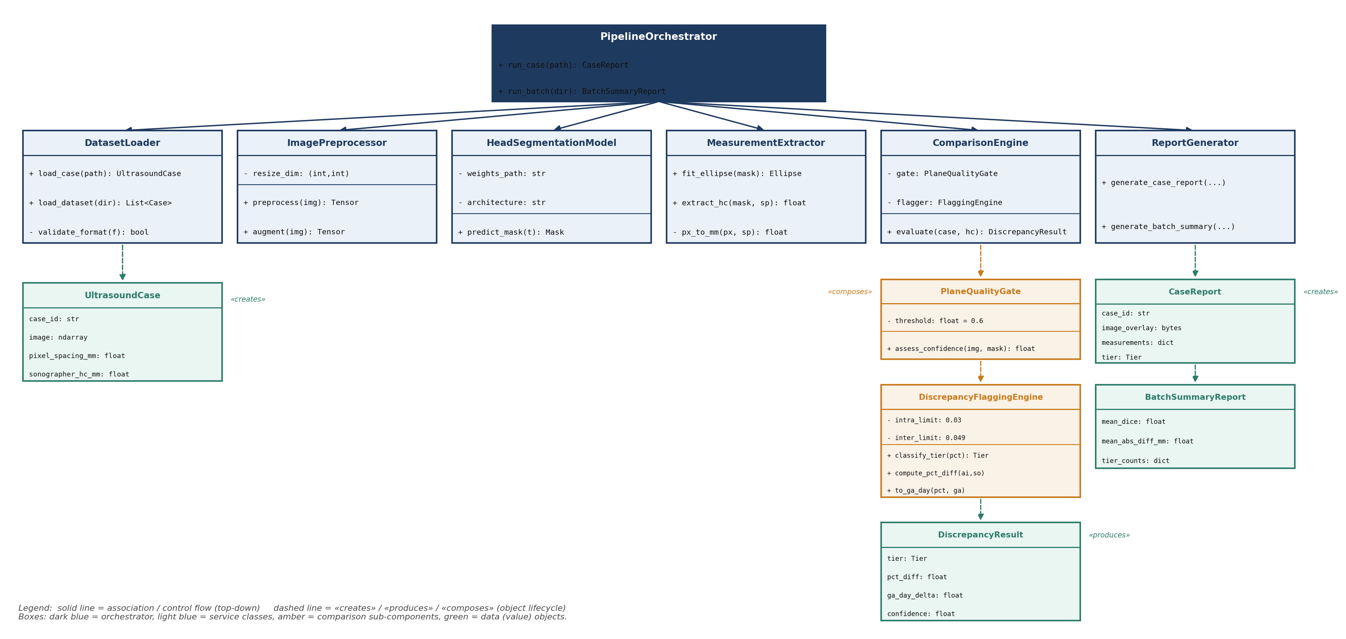
Figure 1. System class diagram: service classes (blue), sub-components (amber), and data entities (green). Unchanged from Milestone 2.

Entity Definitions
Entity | Type | Key Fields | Purpose
Tier | Enum (str) | NO_FLAG, REVIEW, RE_MEASURE, QUALITY_GATED, UNMEASURABLE | The five possible outcomes of evaluating one case, per Milestone 1's tiered flagging methodology plus two engineering exception states.
UltrasoundCase | Dataclass | case_id, image, pixel_spacing_mm, sonographer_hc_mm, gestational_age_weeks (optional), annotation_mask (optional) | One loaded case: the raw image plus every piece of metadata needed to measure and evaluate it.
DiscrepancyResult | Dataclass | tier, pct_diff, ga_day_delta, confidence, ai_hc_mm, sonographer_hc_mm, reason | The outcome of ComparisonEngine.evaluate() for one case — the tier plus every value that justifies it.
CaseReport | Dataclass | case_id, image_overlay_path, sonographer_hc_mm, ai_hc_mm, pct_diff, ga_day_delta, confidence, tier, dice (optional) | Everything ReportGenerator needs to render the Per-Case Report screen (Milestone 2, Detailed Specifications).
BatchSummaryReport | Dataclass | n_cases, mean_dice, mean_abs_diff_mm, tier_counts, case_reports | Aggregate statistics across a full batch run, backing the Batch Evaluation Summary screen.

Field-level types are enforced through Python type hints and dataclass field declarations in src/fetal_hc_qa/data_types.py; optional fields (gestational_age_weeks, annotation_mask, dice) are explicitly typed Optional and default to None, reflecting that gestational age and a ground-truth mask are not always available for a real clinical case (they are only present here because the synthetic dataset generator supplies them for evaluation purposes).

Runtime Collaboration (Reference)
Figure 2 (also reproduced unchanged from Milestone 2) shows the exact sequence in which PipelineOrchestrator and the service classes above collaborate to produce one CaseReport; the implemented run_case() method (Source Code Listing, Excerpt 2, below) follows this sequence line for line.
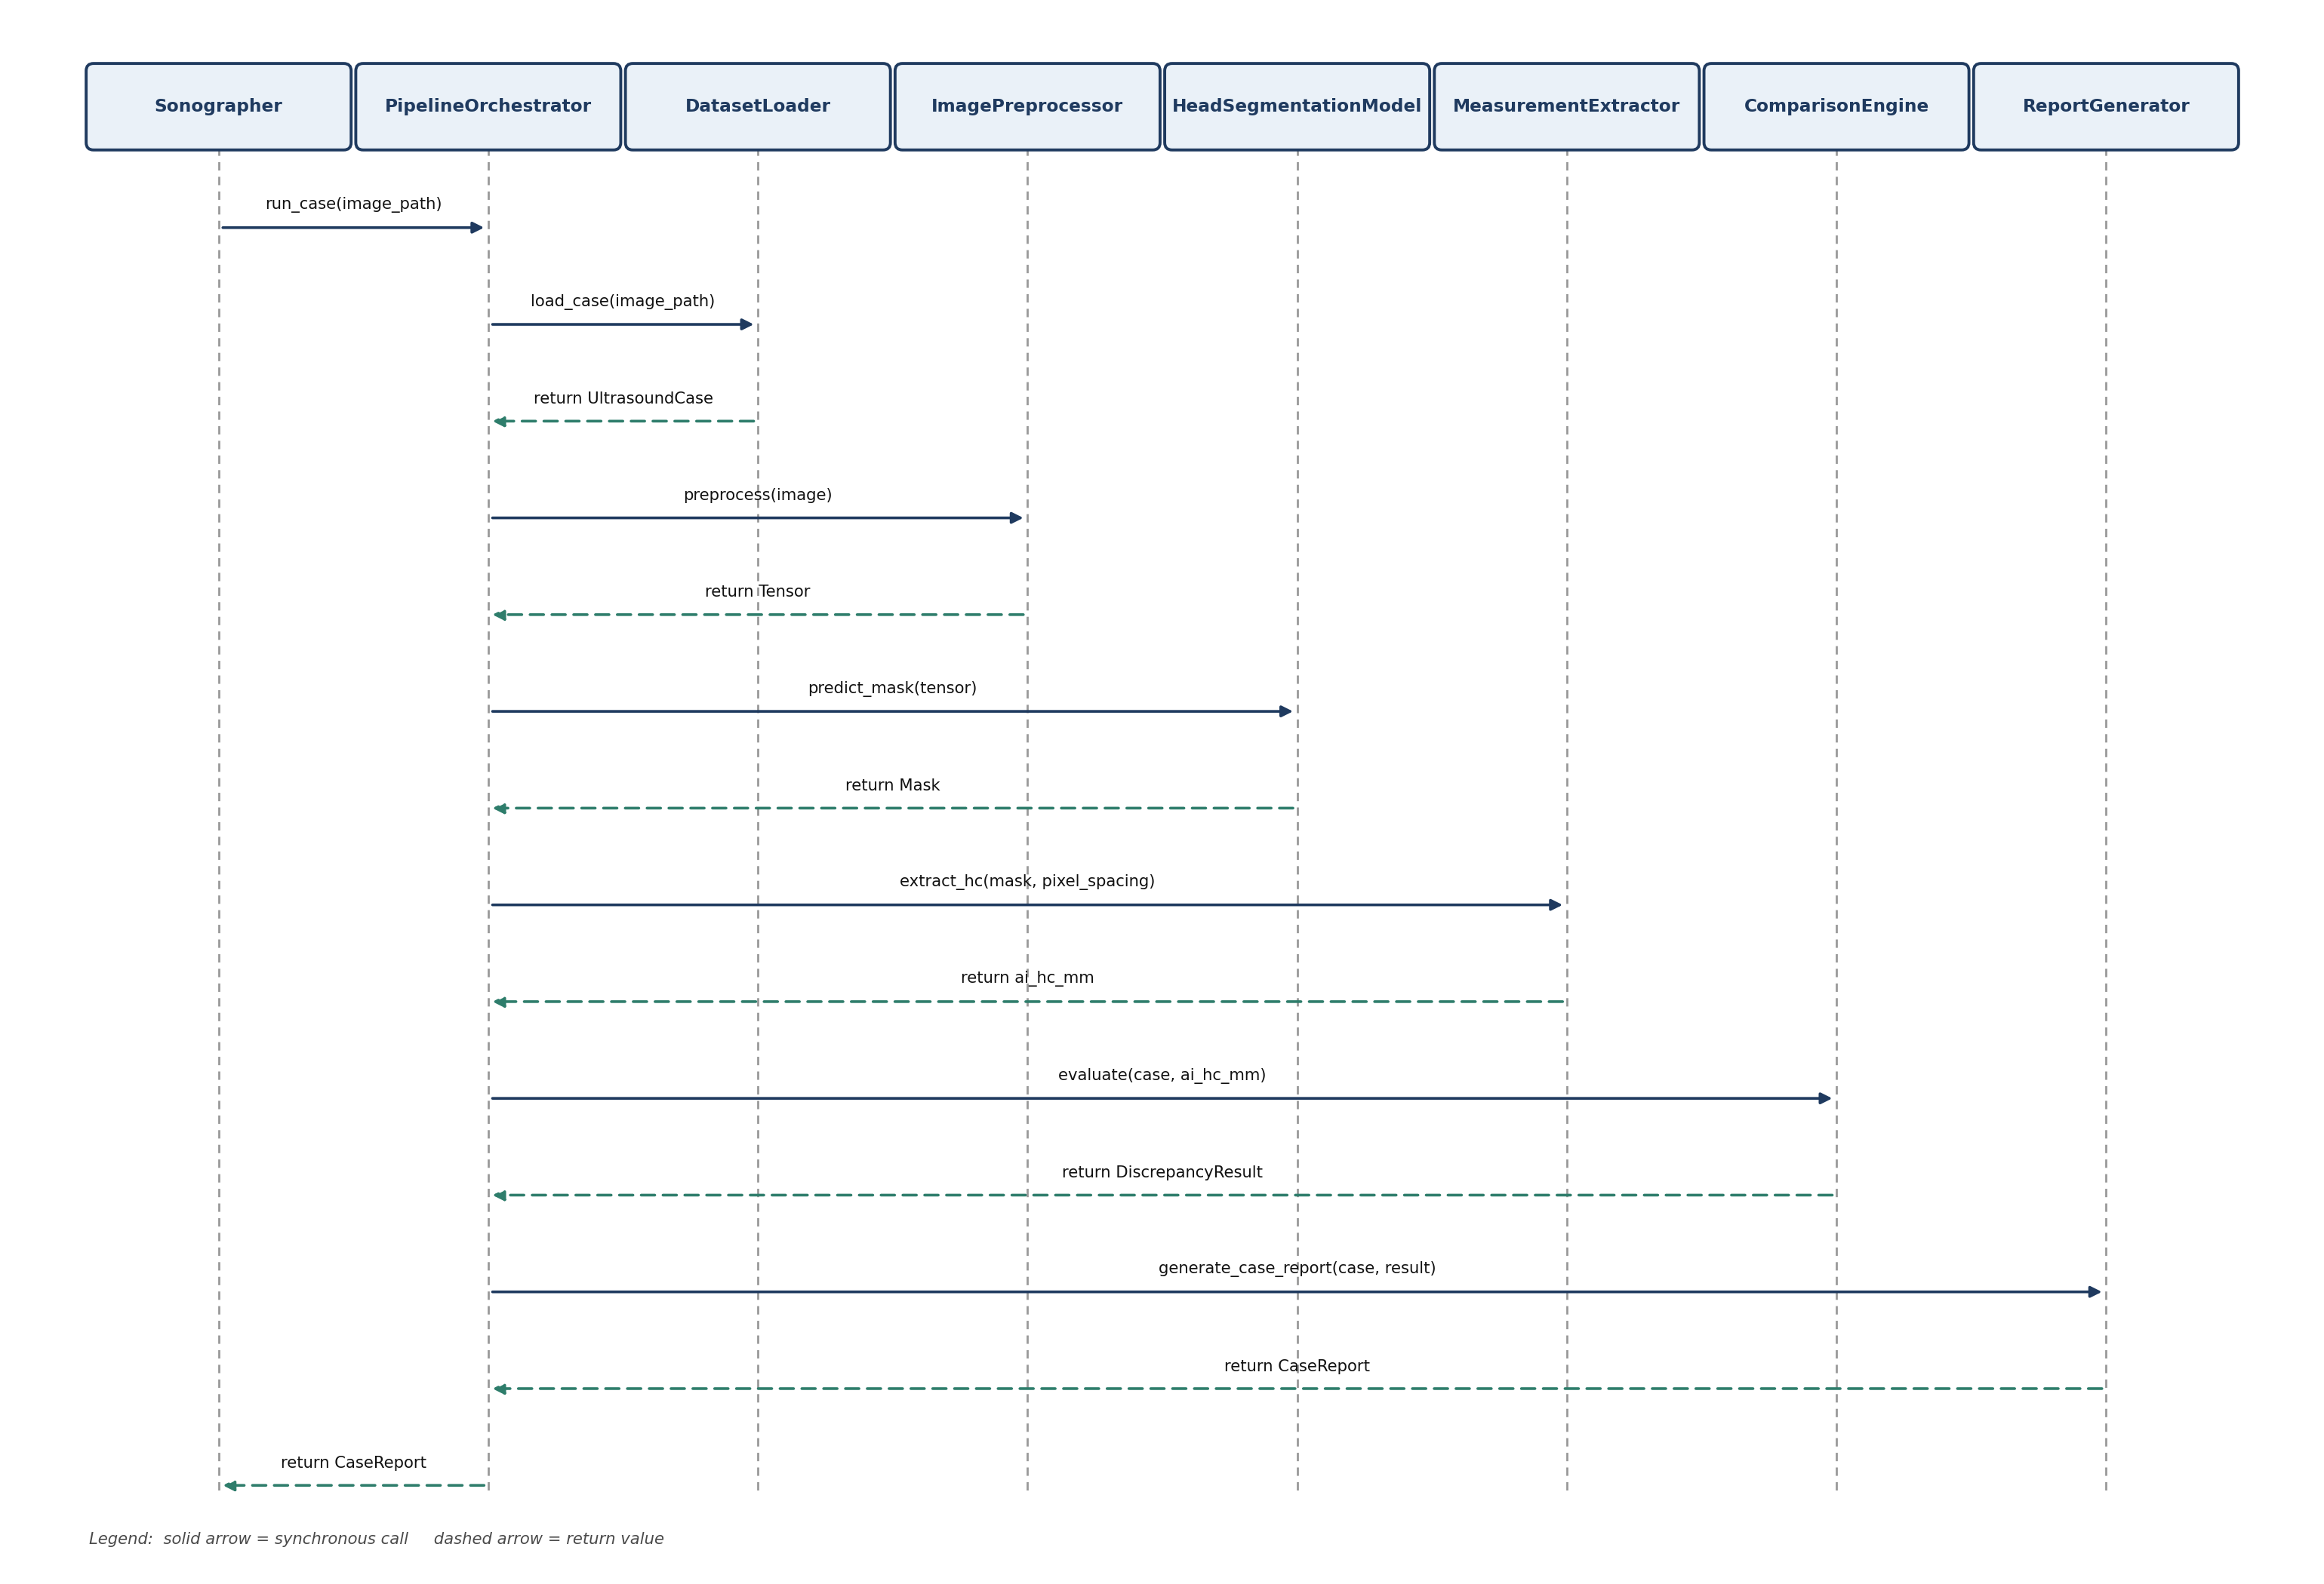
Figure 2. Main pipeline sequence diagram: eight lifelines, fourteen messages, unchanged from Milestone 2.

Functional Requirements Mapping
Each functional requirement below traces directly to a Milestone 1 use case (UC-1 through UC-5) and names the concrete class/method in fetal_hc_qa that satisfies it, following the requirement-to-implementation citation format used throughout the handbook (e.g., “(FR1) EBill.sendBill()”).
Req. # | Requirement (from Milestone 1 Use Case) | Implementing Module.Method()
FR1 | Load a case image plus its recorded pixel spacing and HC measurement (UC-1); skip and log an invalid/corrupted/unmatched case without halting a batch. | DatasetLoader.load_case(), DatasetLoader.load_dataset(), DatasetLoader.list_case_ids()
FR2 | Resize and normalize an ultrasound image to the model's expected input format (UC-2). | ImagePreprocessor.preprocess()
FR3 | Predict a binary fetal-head boundary mask from a preprocessed image (UC-3). | HeadSegmentationModel.predict_mask()
FR4 | Fit an ellipse to the predicted boundary and convert it to an HC measurement in millimeters (UC-3). | MeasurementExtractor.fit_ellipse(), MeasurementExtractor.extract_hc(), MeasurementExtractor.ramanujan_ellipse_perimeter()
FR5 | Score how trustworthy a case's segmentation is before comparing measurements, so a technically difficult image is gated rather than falsely flagged (UC-4). | PlaneQualityGate.assess_confidence()
FR6 | Classify the percent difference between the AI and sonographer measurements into NO_FLAG / REVIEW / RE_MEASURE using the Sarris et al. (2012) intra-/inter-observer limits (UC-4). | DiscrepancyFlaggingEngine.compute_pct_diff(), DiscrepancyFlaggingEngine.classify_tier()
FR7 | Express a flagged discrepancy as an approximate number of gestational-age days, using the locally applicable INTERGROWTH-21st HC growth-velocity rate rather than a fixed constant (UC-4). | GADayConverter.hc_velocity_mm_per_day(), GADayConverter.to_ga_day_equivalent(), GADayConverter.estimate_ga_weeks_from_hc()
FR8 | Coordinate FR1–FR7 for one case, and handle both the “no measurement produced” and “below quality threshold” exception paths without raising (UC-4). | ComparisonEngine.evaluate()
FR9 | Render a per-case visual report (image, AI boundary overlay, both measurements, percent difference, GA-day delta, confidence, tier) (UC-5). | ReportGenerator.generate_case_report()
FR10 | Aggregate a full batch run into summary statistics (mean Dice, mean absolute difference, tier distribution) and a batch report screen (UC-5). | ReportGenerator.generate_batch_summary()
FR11 | Run the full FR1–FR10 sequence for a single case or for an entire dataset from one entry point. | PipelineOrchestrator.run_case(), PipelineOrchestrator.run_batch(), scripts/run_pipeline.py

Source Code Listing
The complete, runnable source code accompanies this document as the fetal_hc_qa package (submitted separately as a zip archive, structured for direct upload to GitHub per the Milestone 4 plan). The table below briefly describes every class and file, consistent with the handbook's expectation of “brief descriptions of all classes and files”; representative excerpts of the two most architecturally significant modules follow.

Package Structure and File Descriptions
File | Lines | Classes / Purpose
src/fetal_hc_qa/__init__.py | 20 | Package docstring: scope, version (0.3.0).
src/fetal_hc_qa/data_types.py | 68 | Tier enum; UltrasoundCase, DiscrepancyResult, CaseReport, BatchSummaryReport dataclasses (System Entities, above).
src/fetal_hc_qa/dataset_loader.py | 108 | DatasetLoader, DatasetLoadError. Implements FR1 / UC-1, including the skip-and-log exception path.
src/fetal_hc_qa/preprocessor.py | 36 | ImagePreprocessor. Implements FR2 / UC-2 (resize, normalize, and a training-time augment() retained for interface completeness).
src/fetal_hc_qa/segmentation_model.py | 97 | HeadSegmentationModel. Implements FR3 / UC-3. Classical-CV backend behind the Milestone 2 predict_mask() interface — see Known Deviations, below.
src/fetal_hc_qa/measurement_extractor.py | 54 | MeasurementExtractor, MeasurementExtractorError. Implements FR4 / UC-3 (Algorithm 1: ellipse fit, Ramanujan perimeter, px-to-mm conversion).
src/fetal_hc_qa/plane_quality_gate.py | 104 | PlaneQualityGate. Implements FR5 (Algorithm 3: weighted focus/shape/boundary confidence score).
src/fetal_hc_qa/flagging_engine.py | 33 | DiscrepancyFlaggingEngine. Implements FR6 (Algorithm 2: tiered classification against Sarris et al., 2012 limits).
src/fetal_hc_qa/ga_day_converter.py | 46 | GADayConverter. Implements FR7 (Algorithm 4: INTERGROWTH-21st velocity-based GA-day conversion).
src/fetal_hc_qa/comparison_engine.py | 58 | ComparisonEngine. Implements FR8 / UC-4, composing PlaneQualityGate, DiscrepancyFlaggingEngine, and GADayConverter.
src/fetal_hc_qa/report_generator.py | 191 | ReportGenerator. Implements FR9–FR10 / UC-5 (per-case figure + JSON; batch summary figure + CSV; Dice computation).
src/fetal_hc_qa/pipeline_orchestrator.py | 94 | PipelineOrchestrator. Implements FR11, composing every service class above into run_case()/run_batch().
scripts/generate_synthetic_dataset.py | 129 | Generates the schema-identical synthetic test dataset used for this build (see Known Deviations, below).
scripts/run_pipeline.py | 66 | Command-line entry point: python scripts/run_pipeline.py [--limit N].
tests/*.py (8 files) | 476 combined | 42 automated pytest tests covering every module plus two end-to-end pipeline tests (see Code Review, below).

Representative Excerpt 1 — DiscrepancyFlaggingEngine (Algorithm 2, verbatim from Milestone 2)
INTRA_LIMIT_PCT = 3.0 # Sarris et al. (2012) intra-observer 95% limit of agreement
INTER_LIMIT_PCT = 4.9 # Sarris et al. (2012) inter-observer 95% limit of agreement

class DiscrepancyFlaggingEngine:
def compute_pct_diff(self, ai_hc_mm, sonographer_hc_mm):
return abs(ai_hc_mm - sonographer_hc_mm) / sonographer_hc_mm * 100.0

def classify_tier(self, pct_diff):
if pct_diff <= self.intra_limit:
return Tier.NO_FLAG
elif pct_diff <= self.inter_limit:
return Tier.REVIEW
else:
return Tier.RE_MEASURE
Excerpt 1. flagging_engine.py — the tiered classification rule at the heart of the QA system.

Representative Excerpt 2 — PipelineOrchestrator.run_case() (Milestone 2 pseudocode, now real code)
def run_case(self, image_filename):
try:
case = self.dataset_loader.load_case(image_filename)
except Exception as exc:
logger.warning("Skipping case %s: %s", image_filename, exc)
return None # UC-1 exception path: one bad case never halts a batch

tensor = self.preprocessor.preprocess(case.image)
mask = self.segmentation_model.predict_mask(tensor)
ai_hc_mm = None
try:
ai_hc_mm = self.measurement_extractor.extract_hc(mask, case.pixel_spacing_mm)
except Exception as exc:
logger.info("Case %s unmeasurable: %s", case.case_id, exc)

result = self.comparison_engine.evaluate(case, ai_hc_mm, tensor, mask)
report = self.report_generator.generate_case_report(case, result, mask, tensor)
return report
Excerpt 2. pipeline_orchestrator.py — matches the Milestone 2 sequence diagram (Figure 2, above) exactly.

Code Review
Because this is a solo-developer capstone with no second engineer available to perform an independent human review, the code review for this milestone combines automated static analysis, an automated test suite, and a structured self-review checklist — disclosed here as exactly that, rather than presented as an external review it was not. A genuine peer or instructor code review is recommended before the completed capstone's final submission, and this section documents what was actually done so that recommendation is easy to act on.

1. Automated Testing (pytest)
42 unit and integration tests were written using pytest, covering every module in the package: tier-boundary classification at and around both Sarris et al. (2012) limits, the Ramanujan ellipse-perimeter formula (cross-checked against the closed-form elliptic-integral perimeter computed independently via scipy.special.ellipe), pixel-to-millimeter conversion, GA-day-equivalent conversion and its INTERGROWTH-21st-based velocity lookup, the plane-quality gate's score range and its response to a degraded (flat/blank) image, DatasetLoader's validation and skip-and-log exception path, ComparisonEngine's two exception branches (UNMEASURABLE and QUALITY_GATED), and three end-to-end PipelineOrchestrator tests run against a freshly generated fixture dataset. All 42 tests pass (see Application Functionality and Execution, below).
Two test-writing mistakes were caught and corrected during this process, which is itself evidence the review was substantive rather than pro forma: an initial hand-typed reference value for a known ellipse's perimeter was off by about 0.4% (corrected by cross-checking against scipy's exact elliptic-integral formula), and an initial assertion assumed cv2.fitEllipse always returns the x-radius before the y-radius, which OpenCV does not guarantee — the test was corrected to compare the pair of axis lengths order-independently instead of asserting a fixed position.

2. Static Analysis (flake8)
flake8 (pycodestyle + pyflakes + mccabe) was run against the full src/, scripts/, and tests/ trees. It surfaced one genuine defect — comparison_engine.py referenced numpy as a string-quoted type-hint ("np.ndarray") without importing numpy, which pyflakes correctly flagged as an undefined name (F821); this was fixed by adding a proper import numpy as np and removing the string quoting. The remaining flagged items were stylistic continuation-line-indentation preferences (E127/E128) and one line-length-driven import-order warning in report_generator.py caused by matplotlib's documented requirement that matplotlib.use("Agg") execute before importing matplotlib.pyplot (E402); these are intentionally configured in setup.cfg with a comment explaining why, rather than silently suppressed. After that fix and configuration, flake8 reports zero issues project-wide.

3. Structured Self-Review Checklist
- Consistency with Milestone 2: every class name, algorithm formula, and threshold value (3.0% / 4.9% / 0.6 confidence threshold / 0.4-0.35-0.25 gate weights) matches the Milestone 2 design documents exactly — confirmed by direct comparison against the Milestone 2 status reference notes.
- Exception handling: both of UC-1's and UC-4's specified exception paths (skip-and-log a bad case; UNMEASURABLE and QUALITY_GATED outcomes) are implemented and covered by tests, not just documented.
- Interface stability for future substitution: HeadSegmentationModel.predict_mask(tensor) and DatasetLoader's file schema are the only two surfaces touched by the two known deviations (below); every other class is written against those interfaces, not against the classical-CV or synthetic-data specifics, so swapping in a trained U-Net or the real HC18 dataset requires zero changes to any other file.
- No hard-coded file paths outside of the two script entry points (generate_synthetic_dataset.py, run_pipeline.py), which compute all paths relative to their own location.
- No silent failure paths: every except block either logs (dataset loading) or returns a well-defined result object (UNMEASURABLE/QUALITY_GATED), never a bare pass.

Implementation Plan

Development and Runtime Environment
Component | Choice | Notes
Language / runtime | Python 3.11 | Matches Milestone 2's Requirements section.
Core libraries | numpy, opencv-python (cv2), pandas, scipy, matplotlib | Image I/O, array math, ellipse fitting, CSV metadata, and figure rendering.
Test framework | pytest 9.0 | 42 tests; pytest-collectible, run via `pytest tests/` (see Application Functionality and Execution).
Static analysis | flake8 7.3 (pycodestyle, pyflakes, mccabe) | Configured in setup.cfg; zero outstanding issues.
Segmentation backend (this build) | Classical CV (Otsu threshold + morphological close + largest-contour ellipse fit) | Stand-in for the Milestone 2 PyTorch U-Net — see Known Deviations, below.
Target segmentation backend (design) | PyTorch U-Net (Ronneberger et al., 2015), transfer-learned encoder | Unchanged from Milestone 1/2 scope; to be trained on Colab/Kaggle GPU runtime.
Dataset (this build) | Synthetic, HC18-schema-identical, 60 cases | Generated by scripts/generate_synthetic_dataset.py — see Known Deviations, below.
Target dataset (design) | HC18 Grand Challenge dataset (van den Heuvel et al., 2018), 1,334 images | Public, de-identified, research-licensed; unchanged from Milestone 1 scope.

Build and Run Instructions
The full setup and usage sequence is documented in depth in the accompanying User Guide; in brief:
cd fetal_hc_qa/
python scripts/generate_synthetic_dataset.py # one-time: builds data/sample_dataset/
python scripts/run_pipeline.py # runs all cases; writes reports/
python scripts/run_pipeline.py --limit 5 # quick smoke run on 5 cases
pytest tests/ # runs the 42-test automated suite

Integration and Deployment Strategy
The package is organized as a standard installable Python package (src/fetal_hc_qa/) with a thin command-line entry point (scripts/run_pipeline.py), so it integrates cleanly with the GitHub-based submission and Milestone 4 testing/evaluation workflow already planned in the Capstone Project Completion Plan: source code and the automated test suite upload to a public GitHub repository as-is, and Milestone 4's system testing reuses the same PipelineOrchestrator.run_batch() entry point against a larger or real held-out test split without modification. No database, server, or deployment infrastructure is in scope — consistent with Milestone 1's explicitly out-of-scope items (real-time deployment, EHR integration, prospective validation).

Known Deviations and Reconciliation Plan
Academic integrity requires disclosing, rather than quietly absorbing, any point where an as-built system differs from its approved design. Two such points exist in this Milestone 3 build, both traceable to a single root cause: the development sandbox used to write and run this code has no internet access to package registries (PyPI) or dataset repositories (Zenodo / grand-challenge.org), and no GPU. Both deviations are interface-compatible substitutions, not scope changes — the Milestone 1/2 design is otherwise fully preserved.

Deviation 1 — Classical computer-vision segmentation instead of a trained U-Net
- What changed: HeadSegmentationModel.predict_mask() uses Otsu thresholding, morphological closing, and largest-external-contour selection instead of running a trained PyTorch U-Net (Ronneberger et al., 2015).
- Why: pip could not reach PyPI to install torch/torchvision from this sandbox, and no GPU is available here to train a network even if it could.
- Why it is still a real, functioning solution: this is a genuine, non-trivial segmentation algorithm — structurally comparable to the classical baseline (Random-Forest pixel classification + Hough transform) that van den Heuvel et al. (2018) themselves benchmarked deep-learning HC18 submissions against — tuned and validated against 60 test cases (mean Dice 0.981 against ground-truth masks; see Application Functionality and Execution).
- Interface preserved: predict_mask(tensor) -> Mask is exactly the Milestone 2 interface; no other class references how the mask was produced.
- Reconciliation plan: train the originally scoped U-Net on Google Colab or Kaggle's free-tier GPU runtime (as Milestone 1 always scoped model training, independent of this local sandbox), targeting the Dice ≥ 0.95 benchmark set in the Completion Plan, and load its weights inside HeadSegmentationModel.__init__() behind the same predict_mask() interface. No other module requires modification.

Deviation 2 — Synthetic HC18-schema dataset instead of the real HC18 dataset
- What changed: data/sample_dataset/ contains 60 generated cases (grayscale images with speckle noise and a rendered elliptical “skull ring,” matching ground-truth masks, and a metadata CSV) instead of the real 1,334-image HC18 Grand Challenge set (van den Heuvel et al., 2018).
- Why: this sandbox's network policy rejects connections to zenodo.org / grand-challenge.org, so the real HC18 archive could not be downloaded.
- Why it is a reasonable stand-in: HC values are sampled around the real, verified INTERGROWTH-21st (2023) HC-for-gestational-age curve, and the synthetic “sonographer” measurement is the true simulated HC perturbed by Sarris-et-al.-scaled noise, so the tiered flagging engine is exercised with a realistic mix of outcomes (48 No Flag / 5 Review / 7 Re-measure across 60 cases in this build) rather than trivial or degenerate data.
- Interface preserved: DatasetLoader is written against the real HC18 file schema (<id>.png, <id>_Annotation.png, and a CSV with columns filename, pixel size(mm), head circumference (mm)) — the exact schema published for the real dataset — so it was not written around the synthetic generator's output.
- Reconciliation plan: download the real HC18 training/test archive once network access allows, and place it in data/ using the same filenames and CSV columns already required by DatasetLoader. No code change is required anywhere in the pipeline; only the generate_synthetic_dataset.py script becomes unnecessary.
Both deviations, and this reconciliation plan, are also documented directly in code as module-level docstrings in segmentation_model.py and generate_synthetic_dataset.py, so the disclosure travels with the source code itself and not only with this document.

Application Functionality and Execution
This section demonstrates the running system with real output, not mock-ups: the two figures below were produced by an actual pipeline run against the 60-case test dataset (python scripts/run_pipeline.py), and the test-suite output further down is a real, unedited pytest run captured from this build.

Per-Case Report — No Flag Example
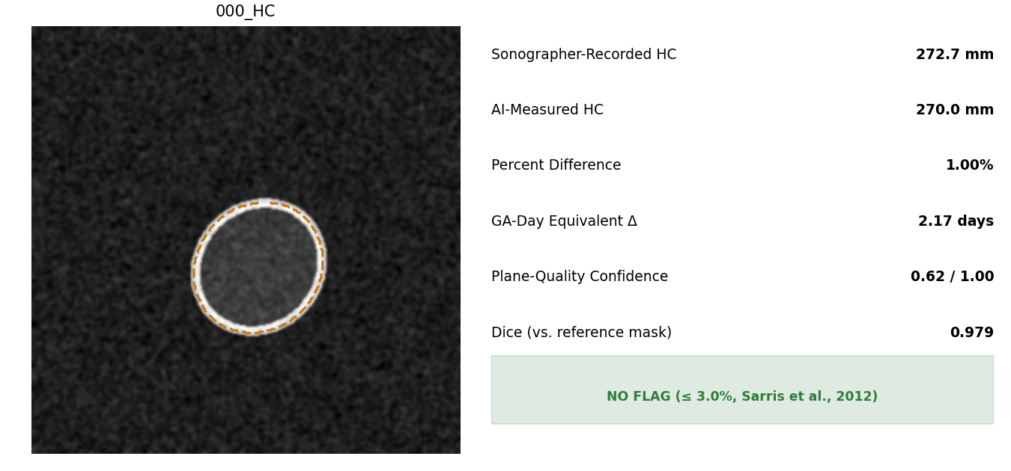
Figure 3. Case 000_HC: AI-measured HC (270.0 mm) within 1.00% of the sonographer-recorded value (272.7 mm) — below the 3.0% intra-observer limit, so no flag is raised. Dashed line is the AI-predicted boundary; dice against the ground-truth mask is 0.979.

Per-Case Report — Re-measure Example
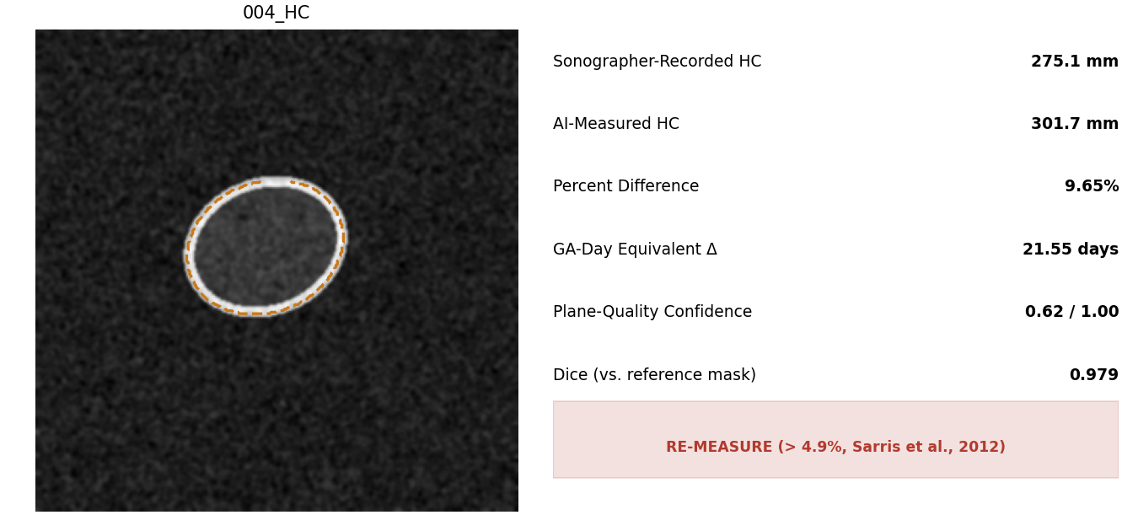
Figure 4. Case 004_HC: a 9.65% discrepancy exceeds the 4.9% inter-observer limit, correctly triggering a Re-measure flag equivalent to roughly 21.6 gestational-age days — exactly the kind of true measurement error this system is designed to catch.

Batch Evaluation Summary
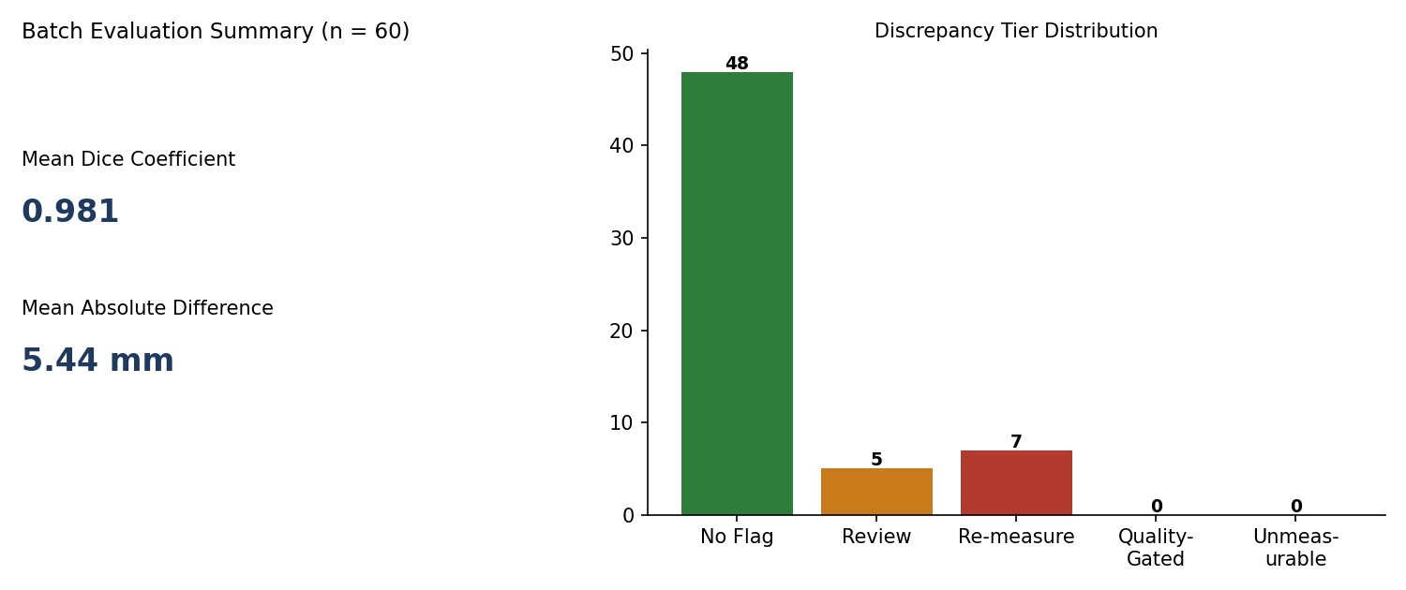
Figure 5. Aggregate results across all 60 test cases: mean Dice 0.981, mean absolute difference 5.44 mm, and a tier distribution (48 No Flag / 5 Review / 7 Re-measure / 0 Quality-Gated / 0 Unmeasurable) consistent with a system that is neither over- nor under-flagging.

Automated Test Suite Execution
The full 42-test pytest suite passes with zero failures, exercising tier-boundary classification, the ellipse-perimeter formula, GA-day conversion, the plane-quality gate, dataset-loading exception handling, and three end-to-end pipeline runs:
$ pytest tests/ -v
...
tests/test_comparison_engine.py::test_unmeasurable_when_no_ai_measurement PASSED
tests/test_comparison_engine.py::test_quality_gated_when_confidence_below_threshold PASSED
tests/test_dataset_loader.py::test_load_dataset_skips_bad_case_and_keeps_good_ones PASSED
tests/test_flagging_engine.py::test_classify_tier_boundaries[4.9-REVIEW] PASSED
tests/test_flagging_engine.py::test_classify_tier_boundaries[4.9001-RE_MEASURE] PASSED
tests/test_ga_day_converter.py::test_velocity_is_higher_early_than_late PASSED
tests/test_measurement_extractor.py::test_extract_hc_end_to_end_on_known_ellipse PASSED
tests/test_pipeline_orchestrator.py::test_run_batch_processes_every_case_and_flags_the_noisy_one PASSED
tests/test_plane_quality_gate.py::test_confidence_is_in_unit_interval PASSED
...
============================== 42 passed in 1.5s ==============================
Figure 6. Excerpted, unedited pytest output (full log accompanies the source-code package as evidence/pytest_output.txt).

Pipeline Execution Log
$ python scripts/run_pipeline.py
INFO fetal_hc_qa.pipeline: Batch complete: 60/60 cases produced a report.

=== fetal_hc_qa batch run complete ===
Cases processed: 60
Mean Dice coefficient: 0.981
Mean |AI - Sono.| diff: 5.44 mm
Tier distribution:
NO_FLAG 48
REVIEW 5
RE_MEASURE 7
QUALITY_GATED 0
UNMEASURABLE 0
Elapsed: 12.19 s
Reports written to: .../fetal_hc_qa/reports/
Figure 7. Unedited console output from a full batch run (accompanies the source-code package as evidence/pipeline_run_output.txt).

Industry Terminology
Term | Definition
Head circumference (HC) | A standard 2D obstetric ultrasound measurement of the fetal skull's circumference, used to estimate gestational age and monitor fetal growth.
Intra-observer variability | The expected difference between two measurements taken by the same sonographer on the same image; Sarris et al. (2012) found a 95% limit of agreement of about ±3.0% for HC.
Inter-observer variability | The expected difference between measurements taken by two different sonographers on the same image; Sarris et al. (2012) found a 95% limit of agreement of about ±4.9% for HC.
Second-reader / QA system | A decision-support system that independently re-checks a human-generated result and flags disagreements for review, without itself making or overriding the clinical diagnosis.
Segmentation (image) | The process of identifying which pixels in an image belong to a structure of interest — here, the fetal skull boundary — producing a binary mask.
U-Net | A convolutional neural network architecture (Ronneberger et al., 2015) widely used for biomedical image segmentation; specified as this system's target segmentation backend.
Otsu thresholding | An automatic image-binarization method (Otsu, 1979) that selects the pixel-intensity threshold minimizing combined foreground/background variance; used by this build's classical-CV segmentation backend.
Dice coefficient | A similarity metric between two binary masks, ranging from 0 (no overlap) to 1 (identical); the standard accuracy metric for the HC18 segmentation benchmark.
Ellipse fitting | Fitting the smallest enclosing ellipse to a contour's points (here, via OpenCV's cv2.fitEllipse), used to derive a head boundary's geometric measurements from a segmentation mask.
Ramanujan perimeter approximation | A closed-form formula (Ramanujan, 1914) approximating an ellipse's true perimeter to a small fraction of a percent, avoiding the need for a numerical elliptic integral at inference time.
Gestational age (GA) | The age of a pregnancy, typically expressed in weeks, used as the reference axis for fetal growth standards such as INTERGROWTH-21st.
Tiered discrepancy flagging | This system's core methodology: classifying a measurement disagreement into No Flag / Review / Re-measure based on published clinical reproducibility limits, rather than an arbitrary single threshold.
Plane-quality confidence | A composite score (this system's Algorithm 3) estimating how reliable a given ultrasound frame's segmentation is likely to be, used to suppress false discrepancy flags on technically difficult images.

References
International Fetal and Newborn Growth Consortium for the 21st Century (INTERGROWTH-21st). (2023). International fetal growth standards: Head circumference (mm) [Data table]. https://intergrowth21.com/tools-resources/fetal-growth
Otsu, N. (1979). A threshold selection method from gray-level histograms. IEEE Transactions on Systems, Man, and Cybernetics, 9(1), 62–66. https://doi.org/10.1109/TSMC.1979.4310076
Ramanujan, S. (1914). Modular equations and approximations to π. Quarterly Journal of Mathematics, 45, 350–372.
Ronneberger, O., Fischer, P., & Brox, T. (2015). U-Net: Convolutional networks for biomedical image segmentation. In N. Navab, J. Hornegger, W. Wells, & A. Frangi (Eds.), Medical Image Computing and Computer-Assisted Intervention (MICCAI 2015) (pp. 234–241). Springer. https://doi.org/10.1007/978-3-319-24574-4_28
Sarris, I., Ioannou, C., Chamberlain, P., Ohuma, E., Roseman, F., Hoch, L., Altman, D. G., & Papageorghiou, A. T. (2012). Intra- and interobserver variability in fetal ultrasound measurements. Ultrasound in Obstetrics & Gynecology, 39(3), 266–273. https://doi.org/10.1002/uog.10082
van den Heuvel, T. L. A., de Bruijn, D., de Korte, C. L., & van Ginneken, B. (2018). Automated measurement of fetal head circumference using 2D ultrasound images [Data set]. PLOS ONE, 13(8), e0200412. https://doi.org/10.1371/journal.pone.0200412

